Automation Interview Questions:

Set 1

WAP java input: Chithra - Output: ahithrc

Code:
public class TransformString {
public static void main(String[] args) {
Scanner scanner = new Scanner(System.in);
System.out.print("Input: ");
String input = scanner.nextLine();
if (input.length() == 0) {
System.out.println("Output: ");
return;
}
char firstChar = Character.toLowerCase(input.charAt(0));
String rest = input.substring(1);
StringBuilder reversed = new StringBuilder(rest).reverse();
reversed.append(firstChar);
System.out.println("Output: " + reversed.toString());
}
}

Output:
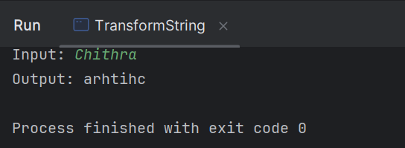

2.Where we use finally block in real time?

Ans: In my project we use the finally block for below scenarios:
* For quitting the browser
* To clear the browser cache

3.What is authentication and authorization in API?

Ans:
Authentication is the process of verifying the identity of a user or system trying to access the API.
Example: | Identity verification | -->Who are you? | -->Login with username/password

Authorization is the process of determining if the authenticated user has permission to perform a certain action or access a specific resource.
Example: Permission check | -->What can you do? | -->Check if user can access /admin

4. What is exception? Exception types?

Ans:
Java Exception: An exception in java is a problem that happens during the execution of the program.
We won't be able to move further in the program, program will exit the normal flow and interrupt the execution.

Exception hierarchy:
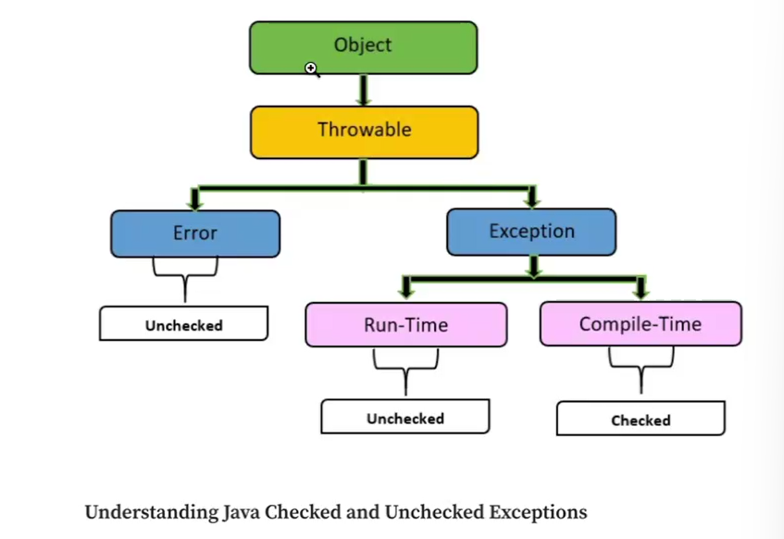

Types of Exception: There are 2 types
- Checked Exception (Compile time exception): The exception which we will get during compile time.
Ex:
IO Exception (Which will get, when we try to read the invalid file),
SQL Exception (Database query exception)
- Unchecked exception (Run time exception): The exceptions are caught during the runtime.
Ex:
NPE (Null Pointer Exception)
Arithmetic exception
ArrayIndexOutOfBound

How to overcome?
*Through Java Exception handling.

Why we need to use java exception handling?
*To prevent the program crashes/ abnormal interruption.

How to handle exception in java?
*We can handle in three different ways:
- Try/Catch blocks
- Throw method
- Throws method

Explain your framework in detail?

Ans:

Currently we are using Cucumber framework with TestNG implementations.
* Our project structure looks like:
Under Project:
*Reports
->extentReport
->htmlReport
->sparkReport
->pdfReport

Under src/test:
src/test:
*context
*pageInitializer
*pageObjects
*stepDefinitions
->hooks
*utilities
->configReader
->driverFactory
->retryListeners
->testNGRetry
*resources
->features
->config.properties
->extent.properties
*xmls
->pom.xml
->testNG.xml
->extengConfig.xml
->log4J.xml
----------------------------------------------------------------------------------------------------------------------
Under src/test: We have packages like
pageObjects--> stepDefinitions --> hooks-->runnerClass-->utility-->pageInitializer-->Context

pageObject- Object repository. We will store all the locators(xpaths,id,name,css), getters and setters(constructors) method for each xpaths.

stepDefinitions- Here we will define the java code for each step written in feature file(Give, when, then, and).
We wil extend the pageInitializer class in stepDefinition class.

hooks- we will add pre conditions and post conditions for scenarios.
We will use annotations to define these pre conditions and post conditions(@Before- setup, confi Reader(qa,dev) @After- tearDown)
We will add screenshot code for failed steps.
--------------------------------------------------------------------------------------------------------------------------------------
runnerClass- we will insert @CucumberOptions, @RunWith tags
@CucumberOptions- features(path of feature files), glue(path of the step definitions),
plugin ={"pretty",
"html:target/Cucumber.html",
"json:target/Cucumber.json",
"junit:target/Cucumber.xml",
"com.aventstack.extentreports.cucumber.adapter.ExtentCucumberAdapter:"
},

dryRun = false,(to check whether all steps are defined or any steps are missed defining, it will not execute the actual code, it will just look for undefined steps if any)

monochrome = true,(for readable format output/report)
tags="@smoke"(which tags do we need to run out of many scenarios and tags)
------------------------------------------------
runnerTestNG- we will not use @RunWith tag bcz we will be having testNG.xml file
rerun plugin- "rerun:target/failedRerun.txt"
------------------------------------------------

runnerFailed-
@CucumberOptions(
plugin ={"pretty",
"html:target/Cucumber.html",
"json:target/Cucumber.json",
"junit:target/Cucumber.xml",
"com.aventstack.extentreports.cucumber.adapter.ExtentCucumberAdapter:",
"timeline:target/parallel-threads",
"rerun:target/failedRerun.txt"
},
dryRun = false,
monochrome = true,
features = {"@target/failedRerun.txt"} ,
glue= {"org.example.StepDefinition"},
tags="@smoke"
)
-----------------------------------------------

Utility: utility folder holds these classes:

configReader- we have created a object for propertied file from where we will fetch the data.

driverFactor- getDriver(initializing the driver object), initDriver(switch statement to select the browser from diff browsers) , quitDriver( quitting the driver instance)

retryListener- retryListerners implements IAnnotationTransformer(interface)

testNGRetry- implements IRetryAnalyzer(interface)
ThreadLocal<Integer>retryCount=ThreadLocal.withInitial(()->0);
private static final int maxRetryCount = 1;

-----------------------------------------------
pageInitializer- we have created
*First- we have mentioned each page objects pages by protected keyword.
*Second- we have created driver object for each step definitions files.

----------------------------------------------
context- we have used methods like- set(), get(), remove(),contains(), clear() to manipulate contextData.
We have added hash map code with key value pair.

----------------------------------------------------------------------------------------------------------
Under resource:
*Features- for each stepDefinition file, one feature will be present. Which holds multiple scenarios.and each scenario holds multiple steps like Given , When, Then , And keyword.

*Config.properties(dev, QA)- Set of user data which we will be fetching for the execution.(Username, password, url, expected output)

*extent.properties- related to extent report generation(what type- PDF,SPARK,HTML). And screenshot path/dir, base64, system Info(Windows)

-----------------------------------------------------------------------------------------------------------
xmlFiles
pom.xml-->dependencies
extent-config.xml-->extent report generation(Chart location, base64, report name, theme)
log4j.xml--> related to logs configuration(date, time)
testNG.xml--> listeners, parallel execution(thread count),runnerClass(testNGRunner)

-----------------------------------------------------------------------------------------------------------------------------------

What is group id and artifact id in maven?

Ans: Maven helps manage:
- Project builds
- Dependencies (libraries your app needs)
- Project structure and versions
And it all revolves around a file called pom.xml (Project Object Model)

Group ID
The groupId represents the unique group or organization that is creating the project. Think of it like a package name in Java or a domain-style identifier.
Ex: <groupId>com.example.myapp</groupId>

Artifact ID
The artifactId is the name of your project/module. It is the actual library or component name that you’re building.
Ex: <artifactId>user-service</artifactId>

What are the different types of error code Explain?
Ans:
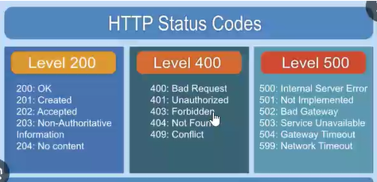

Level 200- Success code
200-OK
201-Created
202-Accepted
203-Non-authoritative Information
204-No content
205- reset content, when adding data to database, receiver didn't receive so it cleared the data.
226-More instances, multiple iterations of same process

Level 400- client error
401-When login credentials are not valid
403-Forbidden restricted
402-Some activity is under process. Like payment under process. Used in finance sector
404-Page not found, when invalid URL or destination URL is not up and running and URL not present. If req is imbalance like more than 100 people accessing the URL(load balance).
405-Method not loaded, resource which is not allowed(Method is not handled)
406-Not acceptable error(req is not under API header call will not be acceptable)
407-Authentication not done(but token is not passing due to authentication proxy failed)
408-Timeout issue(when wait time is beyond the specific time)
409-Conflict(multi edit, passing info multiple times , to protect duplicate 409 is displayed)
410-Req already in use, we cannot handle it again
411-Length is restricted, if truncation is not handled
412-When precondition not met
413-Payload too large
414-URL size
415-When Uploading images it will display unsupported media format
417-Expectation error, not met expectation of the header
421-Mis direction
422-Un-Processible content
423Access is being locked due to maximum reach of failure. ex: ATM 3 attempts failure.

WAP find max and second max using array

Code:
public class secLargestNum {
public static void main(String[] args) {
int[] arr = {10,50,20,100,300,40};
int max1 = Integer.MIN_VALUE; //10
int max2 = Integer.MIN_VALUE; //10
for(int i=0;i<arr.length;i++ ){
if(arr[i]>max1){ //20>50
max2 =max1; //max2 = 10
max1 = arr[i]; //max1=50
}else if(arr[i]>max2 && arr[i]!= max1 ){
max2 = arr[i]; //max2= 20
}
}
System.out.println("Second largest element is :" + max2);
}
}

Output:
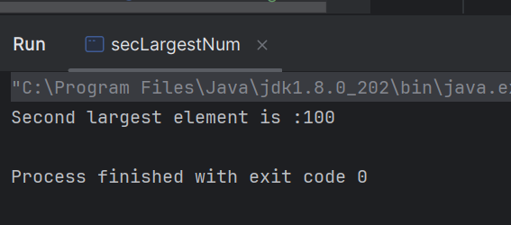

Explain testNg annotations?

Annotation | Purpose
@Test | Marks a method as a test case.
@BeforeMethod | Runs before each test method.
@AfterMethod | Runs after each test method.
@BeforeClass | Runs once before the first method in the current class.
@AfterClass | Runs once after all test methods in the current class.
@BeforeTest | Runs before any test methods in the <test> tag of testng.xml.
@AfterTest | Runs after all test methods in the <test> tag of testng.xml.
@BeforeSuite | Runs before the entire suite starts.
@AfterSuite | Runs after the entire suite ends.
@DataProvider | Supplies data to test methods (for parameterized tests).
@Parameters | Pass parameters from testng.xml to test methods.

How to handle dynamic elements?
Ans:
Dynamic elements are the elements that change their attributes (like id, class, or XPath) every time the page loads or based on user interactions.

We can handle the dynamic elements with below ways:

1.We can use XPath functions like contains () or starts-with ().

Example:
WebElement button = driver.findElement(By.xpath("//*[contains(@id, 'btn_')]"));
WebElement link = driver.findElement(By.xpath("//*[starts-with(@id, 'link_')]"));

2. Use CSS Selectors for Partial Matches
CSS Selectors can also help match dynamic values.
Example:
WebElement input = driver.findElement(By.cssSelector("input[id*='username']"));
*= → contains
^= → starts with
$= → ends with

3. Explicit Wait (WebDriverWait)
Use WebDriverWait to wait for the element to appear or become clickable. This is crucial for dynamic loading.
Example:
WebDriverWait wait = new WebDriverWait(driver, Duration.ofSeconds(10));
WebElement dynamicElement = wait.until(ExpectedConditions.visibilityOfElementLocated(By.id("dynamicId")));
Other conditions:
- elementToBeClickable()
- presenceOfElementLocated()
- invisibilityOfElementLocated()

4. Relative XPath
Avoid depending on volatile attributes like id. Instead, use relative paths from nearby stable elements.
Example:
WebElement label = driver.findElement(By.xpath("//label[text()='Username']"));
WebElement input = driver.findElement(By.xpath("//label[text()='Username']/following-sibling::input"));

5. JavaScriptExecutor (as a last resort)
You can also use JS to access tricky elements.
Example:
JavascriptExecutor js = (JavascriptExecutor) driver;
WebElement element = (WebElement) js.executeScript("return document.querySelector('[id^=\"user_\"]');");

11.How to avoid Stale Reference Element Exception?
Ans:
Stale Reference Element occurs when:
- Web Element is located, but the DOM Structure has changed.
- When the WebElement reference is now "stale" — it's no longer valid.
We can avoid Stale reference Element exception by:
- Use WebDriverWait (Explicit Wait)
- Catch and Retry Logic
- Re-locate the element before interacting with it again

12.Pening----How handle error code in API?

13. What is difference between selenium 3 and selenium 4?

Ans:
Selenium 3.0 Web driver | Selenium 4.0 - Grid
Selenium 3.0 marked the deprecation of Selenium RC and focused on improving WebDriver and grid functionality. | Selenium 4.0 was a major release with a focus on full W3C compliance and introducing new features to enhance automation capabilities.
Removed Selenium RC – RC was no longer actively supported; WebDriver became the default tool.  * W3C WebDriver Protocol Support (Partial) – WebDriver started aligning with the W3C standard but wasn’t fully compliant yet.  * Introduction of geckodriver – Firefox support was migrated from legacy driver to geckodriver.  * Support for mobile automation – Integration with Appium was introduced for mobile testing. | * Full W3C WebDriver Protocol Compliance – WebDriver became fully compliant with the W3C standard, ensuring consistent behavior across browsers.  * Relative Locators – New methods to locate elements relative to other elements (above(), below(), toLeftOf(), toRightOf(), near()).  * Improved Selenium Grid – Enhanced support for parallel execution, better Docker integration, and simpler setup.  * New Window and Tab Management – Direct support for opening and switching between tabs and windows.  * Screenshots of Specific Elements – Ability to take a screenshot of a specific element instead of the entire screen.

14. WAP in java for extract numbers- input: abc123, Output: 123

Code:

public class ExtractNumbers {
public static void main(String[] args) {
String input = "abc123def456gh789";
StringBuilder extractedNumbers = new StringBuilder();
for (int i = 0; i < input.length(); i++) {
char ch = input.charAt(i);
if (Character.isDigit(ch)) {
extractedNumbers.append(ch);
}
}
System.out.println("Extracted Numbers: " + extractedNumbers.toString());
}
}

Output:
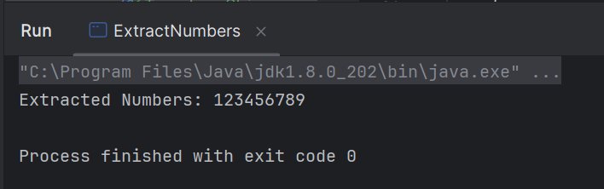

15. Explain your project? Which domain?

BG Refresh- Insurance domain
Bupa Global is a leading international private health insurance company.
Bupa health plans support individuals, families and businesses who are looking for the highest level of cover available from Bupa.
The project Bupa global refresh aims to deliver robust and scalable solution that meets the needs of customers by restructuring the BG.com website.
The introduction of enhanced features in BG.com website helps to extend the business and customer experience.

16. What is methods in java?
A method in Java is a collection of statements grouped together to perform an operation.
It’s a way to re-use code and organize the program better.

17. What is method overriding and method overloading?

Method Overloading | Method Overriding
Overloading meaning having same method name, but different signature → same class | Method overriding means same method name + same signature → subclass changes behavior
Method overloading occurs within the same class | Method overriding occurs between two classes (Super class and Base class)
Since it involves with only one class, Inheritance is not involved | Since overriding occurs between super class and base class, Inheritance is involved.
In overloading return type need not to be same | In Overriding return type must be same
Parameters must be different when we do overloading. | Parameters must be same
Static polymorphism can be achieved using method overloading | Dynamic polymorphism can be achieved by using method overriding

18. Explain oops concept where we use in framework?

Ans:
1: Class- Class is a Blueprint of the real-world objects to create objects.
*We have created individual classes for individual pages or the modules that we want to test in out project.

2: Object- is the instance of the class where we will have class and we will create object.
*We have created a driver object to access it in other classes.

3: Encapsulation- Wrapping up of data into a single unit is encapsulation
*We have created Access modifiers (Getters and setters) to access the locators placed in POM in other classes.

4: Inheritance- Properties from base class/super class/parent class will be inherited from child class/sub class.
*Single level, Multilevel, Hierarchical
*We have extended driver factory class to all other step definitions classes to access the driver object.

5: Polymorphism- method will be having same type with different parameters (Method Overloading, Method Overriding)
*Method Overloading- We have used overloading for setting different arguments for the email Id, Password fields for login.
*Method Overriding- We have overridden the Listener interface and written code for annotations like - @OnTestFail @OnTestSuccess in hooks page.

6: Abstraction- Hiding unnecessary data and showing only essential data to the user.
Here method implementation will not be done in abstract class.
1-using abstract class
2- using interfaces- We have used Listeners as Interfaces, ReTryAnalyzer Interface for rerunning the failed cases.

19. Write a java program for occurrence of each character

Code:
public class OccurenceOfCharacter {
public static void main(String[] args) {
String input = "hello world";
input = input.toLowerCase();
Map<Character, Integer> charCountMap = new HashMap<>();
for (char ch : input.toCharArray()) {
if (ch == ' ') continue;
if (charCountMap.containsKey(ch)) {
charCountMap.put(ch, charCountMap.get(ch) + 1);
} else {
charCountMap.put(ch, 1);
}
}
System.out.println("Character occurrences:");
for (Map.Entry<Character, Integer> entry : charCountMap.entrySet()) {
System.out.println("'" + entry.getKey() + "' : " + entry.getValue());
}
}
}

Output:
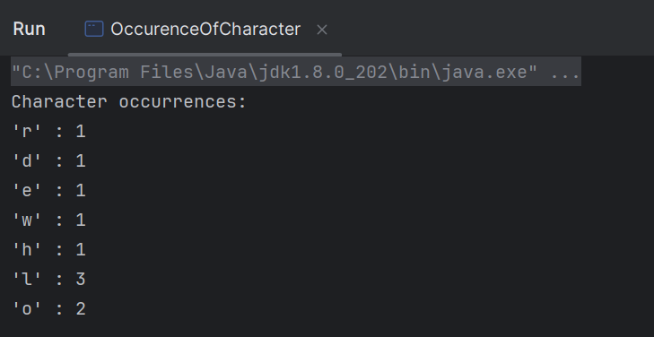

20. Write a java program to find duplicate elements in a string array

Code:
public class DuplicateChar {
public static void main(String[] args) {
char[] inputArray = {'a', 'b', 'c', 'a', 'd', 'e', 'b'};
Map<Character, Integer> charCountMap = new HashMap<>();
for (char ch : inputArray) {
charCountMap.put(ch, charCountMap.getOrDefault(ch, 0) + 1);
}
System.out.println("Duplicate characters:");
for (Map.Entry<Character, Integer> entry : charCountMap.entrySet()) {
if (entry.getValue() > 1) {
System.out.println(entry.getKey() + " : " + entry.getValue());
}
}
}
}

Output:
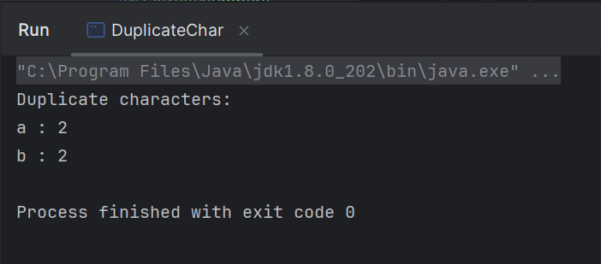

21. Difference between set and list
Ans:
List | Set
Maintains insertion order | No guaranteed order (except in special types like LinkedHashSet or TreeSet)
It Allows duplicates | It doesn’t allow duplicates
Supports indexing (e.g. list.get(0)) | No indexing — you can’t access elements by position
ArrayList, LinkedList | HashSet, LinkedHashSet, TreeSet
When you care about order and duplicates | When you care about uniqueness of elements
Allows multiple nulls | Only one null allowed (in HashSet), TreeSet doesn't allow nulls
Fast for indexed access, slower for search | Fast for search, slower for indexed access (not supported)

22. Where we use collection in framework
Ans:
*We used List with HashMap to store the list of products
*We haven’t used collections in our framework in much places

23. Difference between array and arrayList in Java?

Ans:
Array | ArrayList
Fixed (you set the size when creating it) | Dynamic (resizes automatically as elements are added/removed)
Can store primitive types (e.g. int, char) and objects | Can only store objects (e.g. Integer, String) — not primitives directly
int[] arr = new int[5]; | ArrayList<Integer> list = new ArrayList<>();
arr.length (no method) | list.size()
Manually: arr[0] = 10; | Easy: list.add(10);
Not supported directly — you'd need to shift elements | list.remove(index); — handled for you
Slightly faster for fixed-size use cases | Slight overhead due to resizing and boxing/unboxing
Less flexible | More flexible and convenient
Java language | Java Collections Framework

24. What is basic authentication in API?
Ans:
Basic Authentication (often called Basic Auth) is one of the simplest ways to secure an API. It involves sending a username and password with each API request — but encoded in a specific way.
- We can take username and password.
- We can join them with a colon (:), like this:
Ex: username:password

25. Explain Agile methodologies

Scrum Jargons
Term | What it Means
Sprint | A time-boxed development cycle (usually 1-4 weeks) where a usable product increment is created.
Product Backlog | A prioritized list of features, bug fixes, enhancements, etc., maintained by the Product Owner.
Sprint Backlog | A list of items the team commits to complete in the current sprint. Pulled from the product backlog.
User Story | A small, descriptive requirement told from the user’s perspective: "As a [user], I want [feature] so that [benefit]."
Story Points | A unit of measure for effort/complexity of a user story, not actual time. Think of it as relative sizing.
Product Owner (PO) | Represents the customer. Owns the product backlog and decides what gets built.
Scrum Master | Facilitates Scrum ceremonies, removes blockers, and helps the team follow Agile best practices. Think coach.
Development Team | Cross-functional team that works together to deliver potentially shippable increments.
Daily Stand-up | A short daily meeting (15 mins) where team members share what they did, will do, and if they’re blocked.
Sprint Planning | The team plans which backlog items will be worked on in the sprint. Happens at the start of the sprint.
Sprint Review | Held at the end of the sprint to demo the completed work to stakeholders and get feedback.
Sprint Retrospective | A meeting after the sprint to reflect on what went well, what didn’t, and how to improve next time.
Definition of Done (DoD) | A checklist agreed upon by the team that a story must meet to be considered complete.
Velocity | The number of story points completed in a sprint. Helps forecast future sprints.
Burndown Chart | A visual showing remaining work in the sprint, helping track progress.

26. If I want to run particular test cases multiple times so it is possible to achieve it using testNg ?

Ans:

1. Using invocationCount
This is the simplest way to run a test multiple times.
import org.testng.annotations.Test;

public class SampleTest {

@Test(invocationCount = 5)
public void runMultipleTimes() {
System.out.println("Running test...");
}
}

2. Using @DataProvider
If you want to run a test with different data each time:
import org.testng.annotations.DataProvider;
import org.testng.annotations.Test;

public class DataDrivenTest {

@DataProvider(name = "testData")
public Object[][] data() {
return new Object[][] {
{1}, {2}, {3}
};
}

@Test(dataProvider = "testData")
public void testWithData(int value) {
System.out.println("Running test with value: " + value);
}
}

3. Using Retry Analyzer (for failed test retry)
If you want to retry a test if it fails:
import org.testng.IRetryAnalyzer;
import org.testng.ITestResult;
import org.testng.annotations.Test;

public class RetryTest {

@Test(retryAnalyzer = RetryAnalyzer.class)
public void unstableTest() {
System.out.println("Trying test...");
assert false; // Simulating failure
}
}

class RetryAnalyzer implements IRetryAnalyzer {
int count = 0;
int maxRetry = 3;

@Override
public boolean retry(ITestResult result) {
if (count < maxRetry) {
count++;
return true;
}
return false;
}
}

Method | Use Case
invocationCount | Run test multiple times unconditionally
@DataProvider | Run test with different sets of data
Retry Analyzer | Run test again only if it fails

27. What is data provider in testNG?

A @DataProvider is a method that supplies data to a test method. It allows you to run the same test method with different input values.
It's kind of like a loop for your test, but cleaner and designed specifically for testing with varying data.

Example:
import org.testng.annotations.DataProvider;
import org.testng.annotations.Test;

public class LoginTest {

// 1. Data provider method
@DataProvider(name = "loginData")
public Object[][] dataProviderMethod() {
return new Object[][] {
{"user1", "pass1"},
{"user2", "pass2"},
{"user3", "pass3"}
};
}

// 2. Test method using the data provider
@Test(dataProvider = "loginData")
public void loginTest(String username, String password) {
System.out.println("Logging in with: " + username + " / " + password);
}
}

Things to Know
- The method must return Object[][]
- Each row in the array is one set of test data
- Each column maps to a test method parameter
- You can even pull data from external files like Excel, CSV, DB, etc.

28. What are the various listeners you have used in your project?
In TestNG, listeners are used to hook into the test execution lifecycle. They allow you to perform custom actions like logging, reporting, taking screenshots on failures, etc.

1. ITestListener
🔹 Used For:
- Logging test start, success, failure, skip
- Taking screenshots on failure
- Reporting test outcomes

Methods You Can Override:
onTestStart(), onTestSuccess(), onTestFailure(), onTestSkipped(), onStart(), onFinish()

2. ISuiteListener
🔹 Used For:
- Performing actions before and after the entire test suite runs (like setup/teardown of reports or database connections).

Methods:
onStart(ISuite suite), onFinish(ISuite suite)

3. IInvokedMethodListener
🔹 Used For:
- Executing logic before and after every method (test or config) — great for debugging or setting up method-level resources.

Methods:
beforeInvocation(), afterInvocation()

4. ITestNGListener (Marker Interface)
🔹 Acts as a parent for all listeners — you don't use it directly, but it's good to know

Listener | Used in Projects
ITestListener | Logging, screenshots on failure, reporting
ISuiteListener | Report generation start/end, DB connect/disconnect
IInvokedMethodListener | Log method execution time, set up per-method context

29. What is interface in Java?

Ans:
Interface- is the another way to achieve the abstraction in java.
In interfaces we will not have concrete methods in it and we will have only the method declaration in the interfaces

Interfaces is like a class but it will have "Only method declarations" in it

By using the implemented class we can implement the interface methods in it.

Note:
Keyword- Interface- It is used to define the interface
Keyword- Implements - It is used to implement the interface in the implemented class.

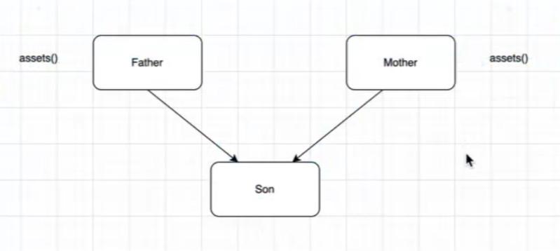
Multiple inheritance in java is not supported. Other way to achieve multiple inheritance is through Interfaces.

30. Difference between interface and abstract class?

Interface | Abstract Class
Defines a contract (what should be done) | Provides a partial implementation (what and how)
Only abstract methods (till Java 7). From Java 8+, can have default, static, and private methods | Can have both abstract and non-abstract (concrete) methods
No constructors allowed | Can have constructors
All variables are public, static, and final (constants) | Can have instance variables (non-final, private, protected, etc.)
A class can implement multiple interfaces (multiple inheritance) | A class can extend only one abstract class (no multiple inheritance)
Methods are implicitly public | Can have any access modifier (public, protected, private)
When you want to define a contract for classes to follow | When you want to share common code among related classes

31. What diamond problem in Java?
The diamond problem occurs in multiple inheritance when a class inherits from two classes that have a common superclass, creating ambiguity.
Example:
A
/ \
B C
\ /
D

Solution-->But Java Does Support Multiple Interfaces
Java allows a class to implement multiple interfaces, and since interfaces (before Java 8) didn’t have method bodies, there was no ambiguity.

32. Which is best CSS Selector or xpath and why?

XPath
XPath (XML Path Language) is a more powerful and flexible language used for selecting nodes in an XML document, and since HTML is a form of XML, it's also widely used for selecting elements in web pages.

Advantages of XPath:
- More Flexible and Powerful: XPath allows you to select elements based on complex conditions (e.g., using functions like contains(), text(), etc.).
- Navigating in Both Directions: XPath can traverse both downward (from parent to child) and upward (from child to parent). This is something that CSS selectors cannot do directly.
- Can Select by Text: XPath can easily locate elements by the exact text content or partial text, whereas CSS cannot do this without tricks like using attribute selectors.
- Ideal for Dynamic Pages: XPath is often preferred in cases where elements might have dynamic IDs, classes, or structures.

When to Use XPath:
- When complex element hierarchy needs to be navigated (e.g., parent-child relationships).
- When you need to select elements based on their text content.
- For dynamic or complex web pages with unpredictable structure.

CSS Selector
CSS Selectors are used to select HTML elements based on their attributes, tags, or relationships to other elements in a page. They are commonly used in styling but are also effective for element selection in automation.

Advantages of CSS Selectors:
- Faster Execution: In most browsers, CSS selectors are faster than XPath because they are native to the browser’s rendering engine.
- Simple Syntax: The syntax is relatively easy to read and write. It's closer to how you would define CSS rules for styling.
- Shorter Expressions: CSS selectors can be more concise compared to XPath expressions for selecting elements.
Better for Static Pages: For simple, static page structures, CSS selectors can be quicker and easier to work with.

When to Use CSS Selectors:
- When you're focusing on speed.
- For simpler, more readable selectors (especially in Selenium or front-end testing).
- When you don’t need to navigate complicated hierarchical relationships (i.e., parents, ancestors).
CSS Selectors | XPath
Faster in most cases | Slower compared to CSS selectors
Simpler and shorter | More complex, especially for advanced queries
Cannot select by text | Can select by exact/partial text
Can only traverse downward (children) | Can traverse both upward and downward
Limited in terms of conditions | Very flexible (contains, starts-with, ends-with, etc.)
All modern browsers support CSS selectors | All modern browsers support XPath
More readable in most cases | Can get complex for advanced selections
Great for simple selections, speed-focused tests | Perfect for dynamic pages and complex queries

33. If have to mention specific condition or element to be visible Which wait will be use?
In Selenium, when we need to wait for a specific condition or element to be visible before interacting with it, the most appropriate wait to use is Explicit Wait.

Explicit Wait in Selenium
An Explicit Wait is used to make the WebDriver wait until a specific condition is met (like an element becoming visible, clickable, etc.). It's more flexible than Implicit Wait because you can specify the exact condition you're waiting for.

Commonly Used ExpectedConditions for Explicit Wait:
- visibilityOfElementLocated(By locator): Waits for the element to be visible.
- elementToBeClickable(By locator): Waits for the element to be both visible and clickable.
- presenceOfElementLocated(By locator): Waits for the element to be present in the DOM (but not necessarily visible).
- textToBePresentInElementLocated(By locator, String text): Waits for the given text to appear in the element.
- invisibilityOfElementLocated(By locator): Waits for the element to be invisible.
- alertIsPresent(): Waits for an alert to appear.

Use Explicit Wait?
- Dynamic Web Pages: In modern web applications, elements may load dynamically after the page is initially loaded (due to AJAX, JavaScript, etc.). Explicit Wait allows you to wait for specific conditions before interacting with elements.
- Avoid Flaky Tests: Explicit waits help to make your tests more reliable by ensuring that elements are ready for interaction before performing actions like clicks, typing, or retrieving text.

34. Why constructor was used in framework?

A constructor is a special method in a class that is called when an instance of the class is created. It is typically used to initialize the object or set up its initial state.
We have used Constructors to create getters and setters method in POM design.
To use those methods in other classes without creating an object of it.

35. Explain pom.xml and where do you use it?

pom.xml is a Maven file used to build, manage, and organize the project.
*pom.xml stands for Project Object Model in Maven. It is an XML file that contains information about the project and configuration details used by Maven to manage the build process.
*It includes details about the project dependencies, plugins, goals, build configurations, repositories, and more.

Purpose of pom.xml
The pom.xml file allows you to:
- Manage Project Dependencies: It specifies external libraries or dependencies your project needs (e.g., Selenium, TestNG).
- Define Plugins and Goals: You can configure Maven plugins to carry out tasks like compiling code, running tests, packaging, and deployment.
- Build Configuration: It helps define how the project should be compiled, tested, and packaged into a final deliverable (JAR, WAR, etc.).
- Version Management: It helps to centralize versioning of dependencies, so you don't need to manually manage versions across multiple files or modules.
- Project Information: It holds metadata such as project name, description, URL, licenses, and maintainers.

36. Pending-----How to find broken links and write code for it?

37. How read and write data in excel sheet?

We can read and write data to excel from:
- .xlsx → Use XSSFWorkbook
- .xls → Use HSSFWorkbook
- Apache POI can handle both read and write operations.
- You can integrate this with TestNG DataProvider for data-driven testing.

Use @dataDriven using testNG
- @DataProvider is a TestNG annotation used to supply data to a test method.
- It returns a 2D array (Object [] []) of data.
- Each set of data is passed to the test method as parameters, and the test is run once per data set.
Example:
import org.testng.annotations.DataProvider;
import org.testng.annotations.Test;
public class LoginTest {
// This is your test method
@Test(dataProvider = "loginData")
public void testLogin(String username, String password) {
System.out.println("Logging in with: " + username + " / " + password);
// Here you'd use Selenium code to perform login and assert results
}
@DataProvider(name = "loginData") // This is your DataProvider method
public Object[][] getData() {
return new Object[][]{
{"user1", "pass1"},
{"user2", "pass2"},
{"admin", "admin123"}
};
}
}

38. Pending----How to enter text in a textbox using Selenium without using Sendkeys()?

There is a text box in which you have to type particularly any data into using selenium automation you can't use sendKeys() which are the other types into a particular textbox using selenium?

1. Using JavaScriptExecutor
This is the most common alternative. It sets the value directly using JavaScript.
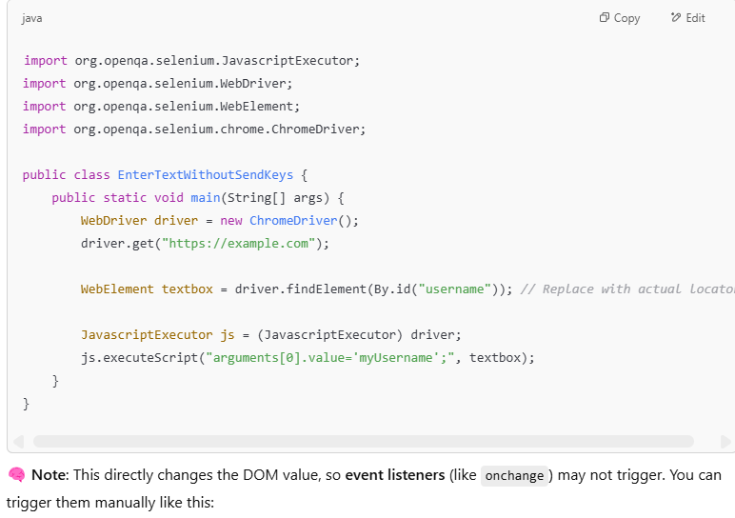

2.Using Actions Class (Not technically avoiding sendKeys, but simulating typing)
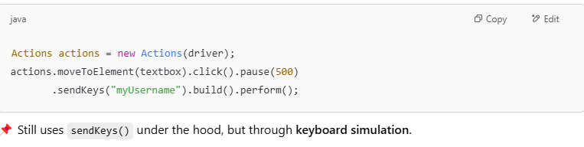

39. How to run your automation?
*Using cucumberRunner
*We can run each scenario in feature file(Cucumber framework)
*Using testNG.xml file

40. What are the challenges that you faced in automation?
Ans:
Challenges faced in my project:
*Dynamic Web Elements / Changing Locators
*Flaky Tests- Tests pass sometimes and fail sometimes without code changes
* Environment Issues- Automation fails due to network instability, backend downtime, or environment mismatch
* Automation Coverage vs Manual- Not all tests can be automated (like CAPTCHA, third-party payments, visual testing).
*Memory issue- Our AVD doesn’t have much space, so sometimes the scripts get failed when we run out of memory.

41. What do you do, if you have a large test suit to execute in less time?
Ans:

Prioritize Tests
- Risk-based testing: Run tests that cover the most critical features or the ones most prone to breaking first.
- Recent changes: Prioritize tests around the modules that were recently modified.
- High-impact areas: UI flows, APIs, security-critical features, etc.

Set 2

1.Compile time and run time polymorphism

Compile time polymorphism is Method Overloading | Run time polymorphism is Method Overriding
Overloading meaning having same method name, but different signature → same class | Method overriding means same method name + same signature → subclass changes behavior
Method overloading occurs within the same class | Method overriding occurs between two classes (Super class and Base class)
Since it involves with only one class, Inheritance is not involved | Since overriding occurs between super class and base class, Inheritance is involved.
In overloading return type need not to be same | In Overriding return type must be same
Parameters must be different when we do overloading. | Parameters must be same
Static polymorphism can be achieved using method overloading | Dynamic polymorphism can be achieved by using method overriding

2.How to handle multiple windows?

We can handle multiple windows by window handle methods:

*getWindowHandle() | -->Returns the current window ID

*getWindowHandles() | -->Returns a set of all window IDs

*switchTo().window(handle) | -->Switches focus to the specified window

3.Explain 401 and 500 error code in API

Level 400- client error
*401-When login credentials are not valid
* The request lacks valid authentication credentials.
* The user is not logged in, provided an invalid token, or token is expired

Level 500 – Internal Server error
* The server encountered an unexpected condition that prevented it from fulfilling the request.

4.What page object model?

Page Object Model (POM) is a design pattern in Selenium used for creating object repositories for web UI elements.
It helps in separating the test code from the page-specific code, making the automation framework more maintainable, reusable, and readable.

5.How do you deal with flaky test cases in automation?

- Investigate every failure. If it's flaky, fix it or remove it.
- Use retry mechanisms for temporary failures (network delays, timeouts).
- Keep test reports clear and actionable, so failures don't pile up.

6.SQL joins

A JOIN clause is used to combine rows from two or more tables, based on a related column between them.

Ex:
SELECT Orders.OrderID, Customers.CustomerName, Orders.OrderDate
FROM Orders
INNER JOIN Customers ON Orders.CustomerID=Customers.CustomerID;

7.Exception handling

How to handle exception in java?
*We can handle in three different ways:
- Try/Catch blocks
- Throw method
- Throws method

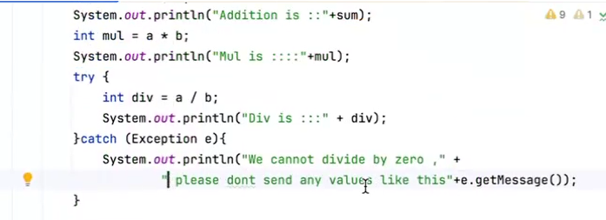

Throws- To make sure when we call the method in main method, we will get to know if exception is handled in the method.
In try catch block, we will not know when it is called, we should see in the code itself.

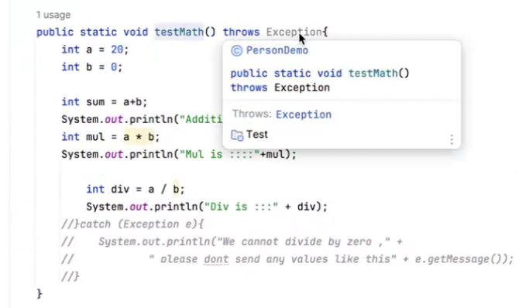

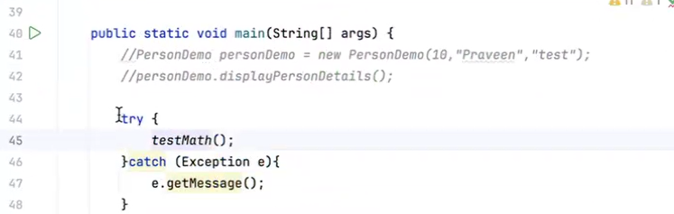

8.How to reverse the words in the string? eg: “I like program language java” to “java language program like I”

Code:
public class ReverseWords {
public static void main(String[] args) {
String input = "I like program language java";
// Step 1: Split the string into words
String[] words = input.split(" ");
// Step 2: Reverse the array of words
StringBuilder reversed = new StringBuilder();
for (int i = words.length - 1; i >= 0; i--) {
reversed.append(words[i]);
if (i != 0) {
reversed.append(" ");
}
}
// Step 3: Print the result
System.out.println("Reversed: " + reversed.toString());
}
}

Output:

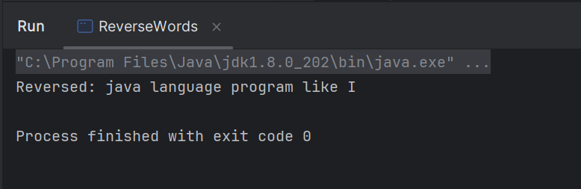

-------------------------------------------------------------------------------------------------------------

9.Using the hashmap, how to find no of occurrences of a character in the string?

Code:

public class CharFrequency {
public static void main(String[] args) {
String input = "JavaProgramming";
HashMap<Character, Integer> charCountMap = new HashMap<>();
// Convert to char array and count each character
for (char c : input.toCharArray()) {
if (charCountMap.containsKey(c)) {
charCountMap.put(c, charCountMap.get(c) + 1);
} else {
charCountMap.put(c, 1);
}
}
// Print the character counts
for (char c : charCountMap.keySet()) {
System.out.println(c + ": " + charCountMap.get(c));
}
}
}

Output:

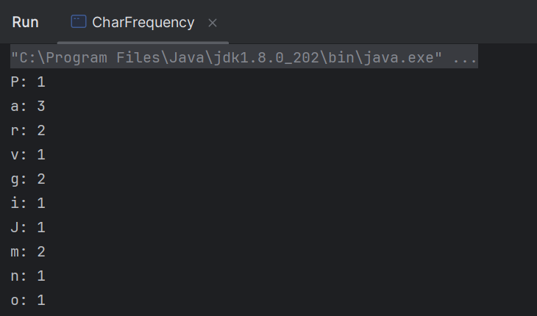

-------------------------------------------------------------------------------------------------------

10.Can the main method be overloaded,
Yes, we can overload main method:
Code:
public class OverloadMainMethod {
public static void main(String[] args) {
System.out.println("Initial main method");
main(5);
}
public static void main(int x) {
System.out.println("We have overloaded the main method" + x );
}
}

Output:
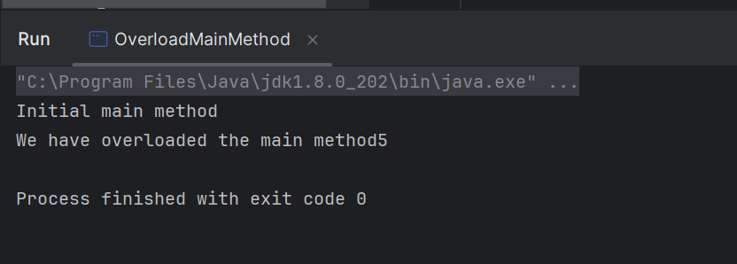
------------------------------------------------------------------------------------------------------

11.can the main method override

No
We can't override the main method in the traditional sense, because:
- main is static, and
- Static methods can't be overridden — they belong to the class, not the instance.

why?
In Java, method overriding only works with instance methods (non-static).
Since main(String[] args) is the entry point of a Java application and is static, it's not part of the object-oriented hierarchy in the usual way.

12.Which access modifiers can be used in an interface?

We can use public and default access modifiers in interface
*public- makes the interface accessible from any other class.
*default- makes the interface accessible within the package when package is private.

13.Access modifiers in Java and its scope?

Access specifiers/Access modifiers

*Determines the visibility or accessibility of the class, methods and variables.
*It will restrict who can access what
*4 types of access specifiers in java
- public
- private
- protected
- Default

public - If we add any class, variable, method as public , that can be accessed anywhere in the project.
By using the public keyword, we are not restricting the class, methods, or variables that can access anywhere in the project.

private: If we add any class, variable, method as private, that can be accessed within class.
We can access within the same class, It is not accessible from any other class.
Why we need to use private?
*We can hide the data which can be visible to the other class

protected- there will be having a factor which feels like a member of same class.
Any class, any variable, method which is marked as protected can be access only within the same package and same class or by the sub-classes(even though if they are in different package)

Difference between public and protected is:
Public can be accessed anywhere in the project, even in other packages and classes.
Protected can be accessed only within same package and class, but not with other packages.

Key Difference between protected and default:
Protected can be access by sub-classes even though in different packages.
Protected can have access to the same package and also for the subclass anywhere in the project.

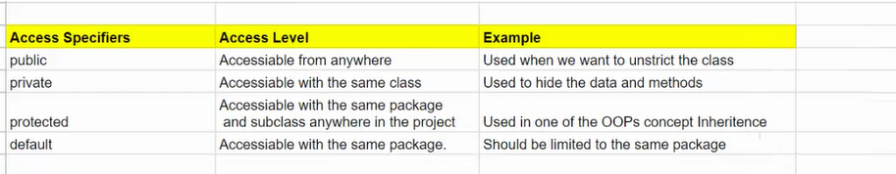

14.What is the difference between scenario and scenario outline?

1. Scenario
- Scenario is Used to define a single test case with specific values.
- Not reusable for different data inputs.
Ex:
Scenario: Login to application using valid username and password
Given As a user I want to launch to the application
And I need to click on Login link
When I enter a valid username
And I enter a valid password
Then I should login successfully

2. Scenario Outline
- Scenario outline is used to run the same test multiple times with different data sets.
- Scenario outline Uses Examples table to define input values.
- Scenario outline is for data-driven testing.
Ex:
cenario Outline: User login with different credentials
Given As a user I want to launch to the application
And I need to click on Login link
When user enters email "<email>" and password "<password>"
And I should click on login
Then the login "<expectedResult>" should be displayed
Examples:
|email|password|expectedResult|
|nayanagr9698@gmail.com|Password!123|Login success|
|nayana@gmail.com |password |Login Failed |
| | |Login error |

15.Can the main method be overloaded?
Yes, we can overload main method:
Code:
public class OverloadMainMethod {
public static void main(String[] args) {
System.out.println("Initial main method");
main(5);
}
public static void main(int x) {
System.out.println("We have overloaded the main method" + x );
}
}

Output:


16.Can the main method be overridden?

No
We can't override the main method in the traditional sense, because:
- main is static, and
- Static methods can't be overridden — they belong to the class, not the instance.

why?
In Java, method overriding only works with instance methods (non-static).
Since main(String[] args) is the entry point of a Java application and is static, it's not part of the object-oriented hierarchy in the usual way.

Pending---17.The client comes and asks you to automate a feature. So how will you proceed? Should you use an existing framework or create a new one if you do not have one in place?

18.What is a feature file in the Cucumber framework?

- In Cucumber framework, a feature file is a plain text file, typically with a ".feature" extension, that describes the behavior and functionality of the software being tested using a structured language called Gherkin.
- Feature file uses Gherkin keywords like Given, When, The, And to create the test case in a readable format.
- Feature files, when combined with step definitions (code that implements the steps), are used by Cucumber to automate acceptance tests.
- Cucumber executes the tests by running the code associated with each step in the feature file.
- The results of the tests are then reported, showing whether the actual behavior of the application matches the expected behavior described in the feature file

19.What is the step definition file used for in cucumber framework?

- Step definition maps the Test Case Steps in the feature files(introduced by Given/When/Then) to code.
- It which executes the steps on Application Under Test and checks the outcomes against expected results.
- For a step definition to be executed, it must match the given steps in a feature.

20.How can you achieve that if you are required to make changes to your selenium files in a maven project?

- Update pom.xml with the right Selenium version (if needed).
- Modify your Selenium test files in the src/test/java/ directory.
- Rebuild the project using Maven (mvn clean install).
- Run tests using mvn test or via your IDE.
- Debug logs and fix issues as needed.
- If necessary, update WebDriver binaries and other dependencies.

21.The syntax for mouse over text in Selenium

Code:
public class MouseHover {
public static void main(String[] args) {
WebDriver driver = new ChromeDriver();
driver.get("https://amazon.com");
WebElement elementToHover = driver.findElement(By.id("menu"));
// Create Actions object
Actions actions = new Actions(driver);
// Perform mouse hover
actions.moveToElement(elementToHover).perform();
// Optionally, interact with submenu or tooltip after hover
WebElement subMenu = driver.findElement(By.id("submenu"));
subMenu.click();
driver.quit();
}
}

22.Can I write: WebDriver driver = new WebDriver()?
No, we cannot write WebDriver driver = new WebDriver
Because:
WebDriver is an interface, not a class. In Java, you cannot instantiate an interface directly.
We must use a concrete class that implements the WebDriver interface, such as ChromeDriver, FirefoxDriver
Ex:
WebDriver driver = new ChromeDriver();

23.Can I access a parent class method using a child class object?

Yes, you can access a parent class method using a child class object in Java — as long as the method is not private.
Ex:
class Parent {
public void show() {
System.out.println("This is parent method");
}
}

class Child extends Parent {
// Inherits show() from Parent
}

public class Main {
public static void main(String[] args) {
Child childObj = new Child();
childObj.show(); // Calls method from Parent
}
}

Output:
This is parent method

Set 3

1.How can you execute failed test cases without manual intervention

*We can execute the failed test cases through failedTestNG.xml file
*We can execute the failed test cases through failedRunner class, where we will have the plugin for rerun , so whenever the scenario gets failed, it will be stored in a rerun file, later we can map the rerun file as a feature file in failedRunner.
Ex:
@CucumberOptions(
plugin ={"pretty",
"html:target/Cucumber.html",
"json:target/Cucumber.json",
"junit:target/Cucumber.xml",
"com.aventstack.extentreports.cucumber.adapter.ExtentCucumberAdapter:",
"timeline:target/parallel-threads",
"rerun:target/failedRerun.txt"
},
dryRun = false,
monochrome = true,
features = {"@target/failedRerun.txt"} ,
glue= {"org.example.StepDefinition"},
tags="@smoke"
)
public class failedRunner extends AbstractTestNGCucumberTests {
}

2.Architecture for Selenium3 and Selenium4

Selenium 3 Architecture
Communication Flow:
- Test Script (written in Java, Python, etc.)
- → talks to → Selenium WebDriver API
- → talks to → JSON Wire Protocol
- → talks to → Browser Driver (e.g., ChromeDriver, GeckoDriver)
- → controls → Browser

Selenium 4 Architecture
Communication Flow:
- Test Script
- → talks to → Selenium WebDriver API
- → uses → W3C WebDriver Protocol (native support)
- → talks to → Browser Driver (e.g., ChromeDriver)
- → controls → Browser
Feature | Selenium 3 | Selenium 4
Protocol | JSON Wire Protocol | W3C WebDriver Protocol (native)
Browser Compatibility | Less consistent | More reliable (due to W3C compliance)
Selenium Grid | Manual, XML-heavy | Modern UI, Docker support, auto-discovery
Relative Locators | Not available | above(), below(), near()
DevTools API Support | Not available | Supports Chrome DevTools

3.What are the factors that we consider when choosing an automation tool?

Factor | Why It Matters
Application Type | Ensures compatibility with app under test
Platform/Browser Support | Covers real-user environments
Language Support | Aligns with team’s skills
CI/CD Integration | Enables continuous testing
Test Maintenance | Reduces long-term effort
Reporting | Helps in debugging and tracking test runs
Cost | Matches budget (open-source vs paid)
Community Support | Ensures longevity and available help
Parallel Execution | Speeds up test execution
API + UI Testing | Enables full-stack validation

4.What is an Action class & mention few methods of action class?
The Actions class in Selenium WebDriver is used to perform complex user interactions (also called advanced interactions) such as:
- Mouse hover (move to element)
- Click and hold
- Right-click (context click)
- Double-click
- Drag and drop
- Keyboard actions (like SHIFT, CTRL, ENTER)

5.Pending--I was asked to write Java code for handling the child window, performing some operations, and switching back to the parent window?

6.What is Velocity in Agile Testing?

Velocity refers to the number of story points completed in a sprint.
It Helps to forecast future sprints.

7.What is a static keyword in Java?

A static keyword is belongs to the class not at the instance level.
*Basically to access any method, we will be creating objects for it every time in different classes,
If we want to access some methods, using Static we can call it with class name
We no need to create instance of the class for static variables.
Variables will be accessed through class level not instance level(object level).

*Static keyword can used to static variables, static block and static methods.

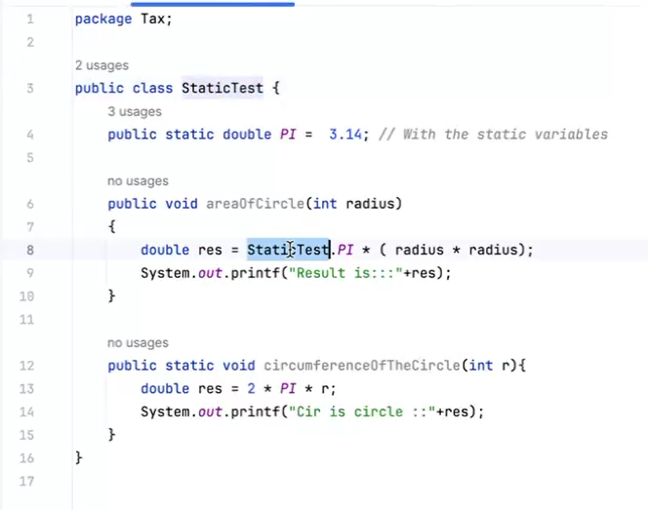

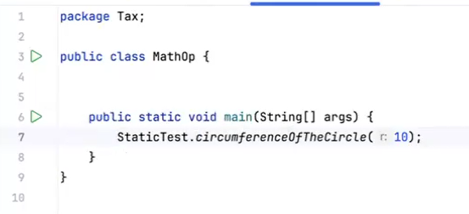

8.Purchase order in amazon-selenium code

Code:
@BeforeMethod
public void openAmazonApplication() throws InterruptedException {
driver =new ChromeDriver();
driver.manage().timeouts().implicitlyWait(Duration.ofSeconds(7));
Thread.sleep(6000);
driver.get("https://www.amazon.in/");
Thread.sleep(5000);
driver.manage().window().maximize();
}

@Test
public void addToCart() throws InterruptedException, IOException {
Properties properties = new Properties();
FileInputStream inputStream = new FileInputStream("resources/logindata.properties");
properties.load(inputStream);
String name= properties.getProperty("username");
String password = properties.getProperty("password");
Thread.sleep(5000);
WebElement searchBox = driver.findElement(By.id("twotabsearchtextbox"));
Thread.sleep(5000);
searchBox.sendKeys("books");
searchBox.submit();
WebElement book = driver.findElement(By.xpath("//span[contains(text(),'Ikigai:')]"));
book.click();
//Get all window handles (tabs)
Set<String> windowHandles = driver.getWindowHandles();
//Iterate through the window handles to switch to the new tab
String originalWindow = driver.getWindowHandle(); // Save the original window handle
for (String windowHandle : windowHandles) {
if (!windowHandle.equals(originalWindow)) {
driver.switchTo().window(windowHandle); // Switch to the new tab
break;
}
}
WebElement addCart = driver.findElement(By.xpath("//a[contains(text(),' Add to Cart ')]"));
addCart.click();
WebElement email = wait.until(ExpectedConditions.visibilityOfElementLocated(By.xpath("//input[@type='email']")));
email.sendKeys(name);
WebElement continueBtn = driver.findElement(By.xpath("//span[@id='continue']"));
continueBtn.click();
WebElement password1 = driver.findElement(By.xpath("//input[@id='ap_password']"));
password1.sendKeys(password);
WebElement Submit = driver.findElement(By.xpath("//input[@id='signInSubmit']"));
Submit.click();

9.All waits-synchronization

Implicit Wait
- Applied globally for the lifetime of the WebDriver instance.
- Tells WebDriver to wait for a certain amount of time while trying to find an element
Ex: driver.manage().timeouts().implicitlyWait(Duration.ofSeconds(10));

Explicit Wait (WebDriverWait)
- Waits for a specific condition to occur before proceeding.
- Uses the ExpectedConditions class.
Ex: WebDriverWait wait = new WebDriverWait(driver, Duration.ofSeconds(10));
WebElement element = wait.until(ExpectedConditions.visibilityOfElementLocated(By.id("username")));

Fluent Wait
- A more flexible version of WebDriverWait.
- Allows you to define:
  - Polling frequency
  - Ignored exceptions
  - Timeout
Ex: Wait<WebDriver> fluentWait = new FluentWait<>(driver)
.withTimeout(Duration.ofSeconds(15))
.pollingEvery(Duration.ofSeconds(2))
.ignoring(NoSuchElementException.class);

WebElement element = fluentWait.until(driver1 -> driver1.findElement(By.id("email")));

How to select all the checkboxes In the application, not in the drop-down

public class SelectAllCheckboxes {
public static void main(String[] args) {
WebDriver driver = new ChromeDriver();
driver.get("https://abc.com"); // Replace with your URL

// Locate all checkbox elements (adjust locator as needed)
List<WebElement> checkboxes = driver.findElements(By.xpath("//input[@type='checkbox']"));

// Iterate and click each checkbox if not already selected
for (WebElement checkbox : checkboxes) {
if (!checkbox.isSelected()) {
checkbox.click();
}
}

driver.quit();
}

11. What are the dependencies used in your project

We have used several dependencies in our project, they are as follows:
*junit
*cucumber-java
*cucumber-junit
*cucumber-core
*cucumber-reporting
*extentreport-cucumber7-adapter
*Selenium-java
*testing
*cucumber-testng
*log4j-core
*log4j-api
*log4j-slf4j2-impl

Set 4

1.How solve merge conflict in git

Merge conflict - Occurs when two diff dev's working on the same file at same time, when one will push his code and other will pull his code , merge conflicts will happen.
Because, it is unable to understand which code to keep and which not

3 ways to resolve:
- Keep head and remove last changes
- Keep both, remove all indications and save
- Keep my changes, remove head

2.What is git stash

If we try to switch branch before adding file to staging area, we can see stash option.

git stash- It is used to store or save the changes temporarily

git stash (It saves current work which we have done to any file in that branch)
git stash save

How to see , what is saved?
git stash list (it displays list of stash of files)

To continue with the work/revert back to stashed file?
git stash pop - is used to restore the stashed file or saved files but it will permanently remove from the list
git stash apply -- is used to restore the saved file , it doesn't delete the file from the list/stashed list.

3. How to integrated test cases through Jenkins explain flow?

Steps to integrate the test cases through Jenkins:
*Install Jenkins (if not already available)
*Install required Jenkins plugin- Manage Jenkins → Manage Plugins → Available
*Create your test cases through Selenium
*Commit your changes
*Push the code to remote repository.
*Open Jenkins and create new Maven job (Enter Job name, select maven project)
*Configure source code (add the remote repo url and credentials if the repo is private)
*Add build steps (Select “Invoke top-level Maven targets" for Maven)
*Add post build steps (Publish HTML report, Publish Junit report)
*Trigger build automatically (schedule - Build periodically for scheduled runs)
*Save and Run the job (Click Build now)

Where we use polymorphism in selenium framework?

Overloading in framework- we have created a base class for common actions (such as click, send keys, etc.), and then extend this base class for specific page objects.
Each page class can have its own specific functionality, while still leveraging common functionality from the base class.

Overriding in framework- We have implemented Listener interface methods in hooks class.
We have implemented Listener interface methods like onTestPass, onTestFail, onTestStart.

5. How handle dynamic elements?

Ans:
Dynamic elements are the elements that change their attributes (like id, class, or XPath) every time the page loads or based on user interactions.

We can handle the dynamic elements with below ways:

1.We can use XPath functions like contains () or starts-with ().

Example:
WebElement button = driver.findElement(By.xpath("//*[contains(@id, 'btn_')]"));
WebElement link = driver.findElement(By.xpath("//*[starts-with(@id, 'link_')]"));

2. Use CSS Selectors for Partial Matches
CSS Selectors can also help match dynamic values.
Example:
WebElement input = driver.findElement(By.cssSelector("input[id*='username']"));
*= → contains
^= → starts with
$= → ends with

3. Explicit Wait (WebDriverWait)
Use WebDriverWait to wait for the element to appear or become clickable. This is crucial for dynamic loading.
Example:
WebDriverWait wait = new WebDriverWait(driver, Duration.ofSeconds(10));
WebElement dynamicElement = wait.until(ExpectedConditions.visibilityOfElementLocated(By.id("dynamicId")));
Other conditions:
- elementToBeClickable()
- presenceOfElementLocated()
- invisibilityOfElementLocated()

4. Relative XPath
Avoid depending on volatile attributes like id. Instead, use relative paths from nearby stable elements.
Example:
WebElement label = driver.findElement(By.xpath("//label[text()='Username']"));
WebElement input = driver.findElement(By.xpath("//label[text()='Username']/following-sibling::input"));

5. JavaScriptExecutor (as a last resort)
You can also use JS to access tricky elements.
Example:
JavascriptExecutor js = (JavascriptExecutor) driver;
WebElement element = (WebElement) js.executeScript("return document.querySelector('[id^=\"user_\"]');");

6. Write a selenium code for amazon search box Enter laptops print first five laptops name

Code:
public class AmazonLaptop {
public static void main(String[] args) {
// Set path to the chromedriver (make sure to set the correct path)
System.setProperty("webdriver.chrome.driver", "path/to/chromedriver");
// Initialize the WebDriver
WebDriver driver = new ChromeDriver();
driver.get("https://www.amazon.com");
// Wait until the search box is present
WebDriverWait wait = new WebDriverWait(driver, 5);
WebElement searchBox = wait.until(ExpectedConditions.presenceOfElementLocated(By.id("twotabsearchtextbox")));
// Enter "laptops" into the search box and submit the search
searchBox.sendKeys("laptops");
searchBox.submit();
// Wait for the results to load
wait.until(ExpectedConditions.presenceOfElementLocated(By.cssSelector(".s-main-slot")));
// Locate the list of laptop names (adjust the XPath according to the actual page structure)
List<WebElement> laptopNames = driver.findElements(By.xpath("//span[@class='a-text-normal']"));
// Print the names of the first 5 laptops
System.out.println("First 5 laptops on Amazon:");
for (int i = 0; i < 5 && i < laptopNames.size(); i++) {
System.out.println((i + 1) + ". " + laptopNames.get(i).getText());
}
// Close the browser
driver.quit();
}
}

7. Write a java program to count unique elements input: SSSRJTEH

Code:
public class UniqueElements {
public static void main(String[] args) {
String input = "SSSRJTEH"; // Input string
// Create a HashMap to store the frequency of each character
Map<Character, Integer> charCountMap = new HashMap<>();
// Iterate through the string and count character frequencies
for (int i = 0; i < input.length(); i++) {
char currentChar = input.charAt(i);
charCountMap.put(currentChar, charCountMap.getOrDefault(currentChar, 0) + 1);
}
// Print unique elements (characters that appear only once)
System.out.println("Unique characters:");
for (Map.Entry<Character, Integer> entry : charCountMap.entrySet()) {
if (entry.getValue() == 1) {
System.out.println(entry.getKey());
}
}
}
}

Output:
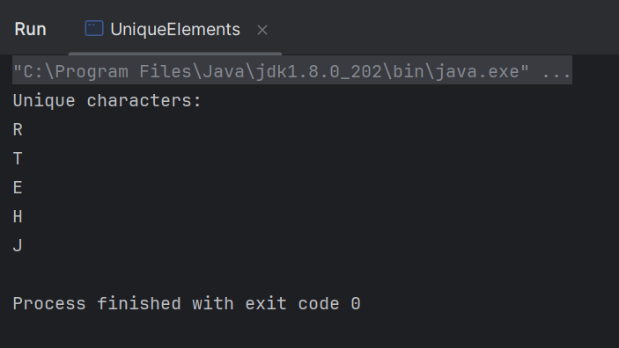

8. What POM?

Page Object Model (POM) is a design pattern in Selenium used for creating object repositories for web UI elements.
It helps in separating the test code from the page-specific code, making the automation framework more maintainable, reusable, and readable.

9. Write a java program to 35% of 5 lakh?

Code:
public class Calculate {
public static void main(String[] args) {
double totalAmount = 500000; // 5 lakh
double percentage = 35;
double result = (percentage / 100) * totalAmount;
System.out.println("35% of 5 lakh is: " + result);
}
}

Output:
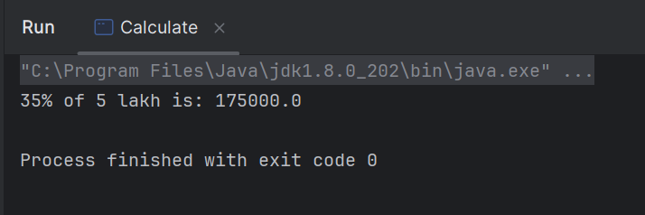

10. How run test cases through Jenkins explain flow?

Steps to integrate the test cases through Jenkins:
*Install Jenkins (if not already available)
*Install required Jenkins plugin- Manage Jenkins → Manage Plugins → Available
*Create your test cases through Selenium
*Commit your changes
*Push the code to remote repository.
*Open Jenkins and create new Maven job (Enter Job name, select maven project)
*Configure source code (add the remote repo url and credentials if the repo is private)
*Add build steps (Select “Invoke top-level Maven targets" for Maven)
*Add post build steps (Publish HTML report, Publish Junit report)
*Trigger build automatically (schedule - Build periodically for scheduled runs)
*Save and Run the job (Click Build now)

Java Programs

1.Write a java program print alphabets, Numbers, total character of string

Code:
public class CharacterAnalysis {
public static void main(String[] args) {
String input = "N165$J SFD";
StringBuilder alphabets = new StringBuilder();
StringBuilder numbers = new StringBuilder();
int totalCharacters = 0;
for (int i = 0; i < input.length(); i++) {
char ch = input.charAt(i);
if (Character.isAlphabetic(ch)) {
alphabets.append(ch);
} else if (Character.isDigit(ch)) {
numbers.append(ch);
}
totalCharacters++;
}
System.out.println("Alphabets: " + alphabets);
System.out.println("Numbers: " + numbers);
System.out.println("Total characters: " + totalCharacters);
}
}

Output:
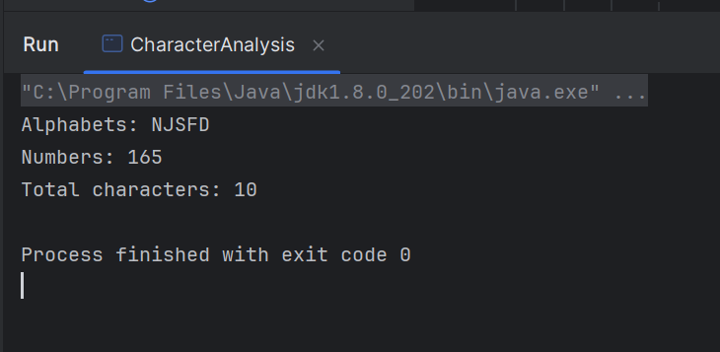

2.Write a java program to find duplicate character in an array

Code:
public class DuplicateChar {
public static void main(String[] args) {
char[] inputArray = {'a', 'b', 'c', 'a', 'd', 'e', 'b'};
Map<Character, Integer> charCountMap = new HashMap<>();
for (char ch : inputArray) {
charCountMap.put(ch, charCountMap.getOrDefault(ch, 0) + 1);
}
System.out.println("Duplicate characters:");
for (Map.Entry<Character, Integer> entry : charCountMap.entrySet()) {
if (entry.getValue() > 1) {
System.out.println(entry.getKey() + " : " + entry.getValue());
}
}
}
}

Output:
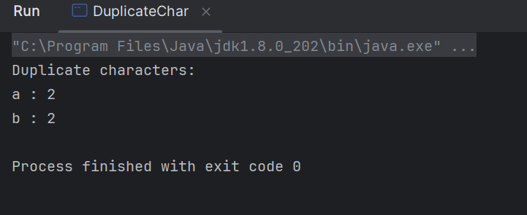

3- Write a java program to extract Numbers

Code:
public class ExtractNumbers {
public static void main(String[] args) {
String input = "abc123def456gh789";
StringBuilder extractedNumbers = new StringBuilder();
for (int i = 0; i < input.length(); i++) {
char ch = input.charAt(i);
if (Character.isDigit(ch)) {
extractedNumbers.append(ch);
}
}
System.out.println("Extracted Numbers: " + extractedNumbers.toString());
}
}

Output:
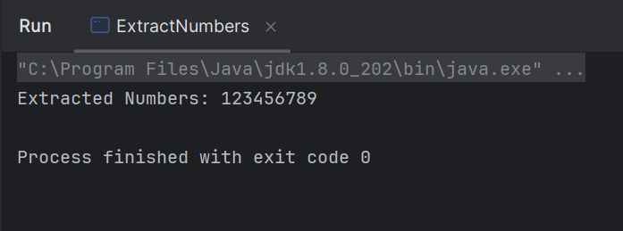

4- WAP factorial in java

Using a Loop (Iterative Approach)

Code:
public class Factorial {
public static void main(String[] args) {
// Create Scanner object to take user input
Scanner scanner = new Scanner(System.in);
// Prompt user for input
System.out.print("Enter a number: ");
int number = scanner.nextInt();
// Initialize result
long factorial = 1;
// Calculate factorial using a loop
for (int i = 1; i <= number; i++) {
factorial *= i;
}
// Output the result
System.out.println("Factorial of " + number + " is " + factorial);
}
}

Output:
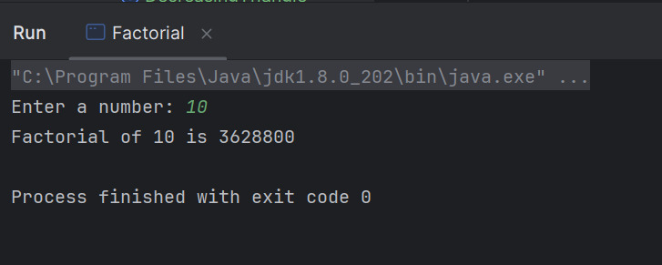

5- Max element in array
- Write a java program to find largest of element in an array
- public class largestElement {
//WAP to find the largest element in an array
public static int findLargest(int[] arr) {
//int max = arr[0];
int max= Integer.MIN_VALUE;
for (int i = 0; i < arr.length; i++) {
if (arr[i] > max) {
max = arr[i];
}
}
return max;
}
public static void main(String[] args) {
int[] arr = {10, 500, 30, 300, 700, 900};
System.out.println("The largest element in the array is: " + findLargest(arr));
}
}

6- Second max element in array
6. Write a java program to find max and second max Numbers using array
- public class secLargestNum {
public static void main(String[] args) {
int[] arr = {10,50,20,100,300,40};
int max1 = Integer.MIN_VALUE; //10
int max2 = Integer.MIN_VALUE; //10
for(int i=0;i<arr.length;i++ ){
if(arr[i]>max1){ //20>50
max2 =max1; //max2 = 10
max1 = arr[i]; //max1=50
}else if(arr[i]>max2 && arr[i]!= max1 ){
max2 = arr[i]; //max2= 20
}
}
System.out.println("Second largest element is :" + max2);
}
}

7- Check Palindrome
- Palindrome

Checking Palindrome for a String

Code:
public class Palindrome {
public static void main(String[] args) {
// Create Scanner object to take user input
Scanner scanner = new Scanner(System.in);
// Prompt user for input
System.out.print("Enter a string: ");
String input = scanner.nextLine();
// Remove spaces and convert to lowercase for case-insensitive comparison
input = input.replaceAll("\\s", "").toLowerCase();
// Initialize a flag variable to track if it's a palindrome
boolean isPalindrome = true;
// Loop to check characters from both ends
for (int i = 0; i < input.length() / 2; i++) {
if (input.charAt(i) != input.charAt(input.length() - 1 - i)) {
isPalindrome = false;
break;
}
}
// Output the result
if (isPalindrome) {
System.out.println(input + " is a palindrome.");
} else {
System.out.println(input + " is not a palindrome.");
}
}
}

Output:
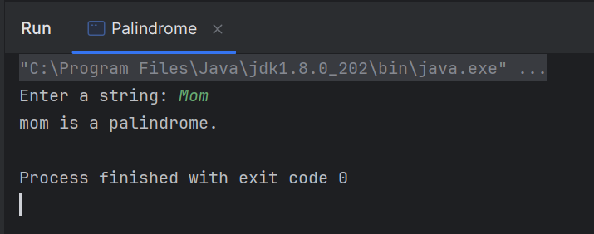

Checking Palindrome for a Number

Code:
public class PalindromeNumber {
public static void main(String[] args) {
// Create Scanner object to take user input
Scanner scanner = new Scanner(System.in);
// Prompt user for input
System.out.print("Enter a number: ");
int number = scanner.nextInt();
// Store the original number to compare later
int originalNumber = number;
// Reverse the number
int reversed = 0;
while (number != 0) {
int digit = number % 10;
reversed = reversed * 10 + digit;
number /= 10;
}
// Check if original number is equal to the reversed number
if (originalNumber == reversed) {
System.out.println(originalNumber + " is a palindrome.");
} else {
System.out.println(originalNumber + " is not a palindrome.");
}
}
}

Output:

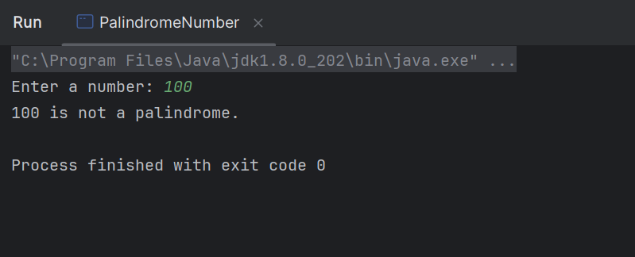

8- WAP to find a Prime number in Java

Code:
public class PrimeNumber {
public static void main(String[] args) {
// Create Scanner object to take user input
Scanner scanner = new Scanner(System.in);
// Prompt user for input
System.out.print("Enter a number: ");
int number = scanner.nextInt();
// Check if the number is prime
if (isPrime(number)) {
System.out.println(number + " is a prime number.");
} else {
System.out.println(number + " is not a prime number.");
}
}
// Method to check if a number is prime
public static boolean isPrime(int num) {
// Prime numbers are greater than 1
if (num <= 1) {
return false;
}
// Check divisibility from 2 to square root of the number
for (int i = 2; i <= Math.sqrt(num); i++) {
if (num % i == 0) {
return false; // Not prime if divisible by any number other than 1 and itself
}
}
return true; // Number is prime if not divisible by any number up to its square root
}
}

Output:
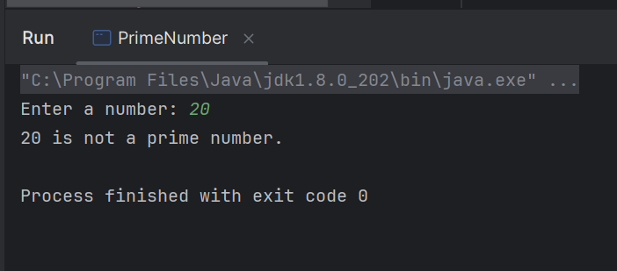

9- Write a java program to remove duplicate string

Code:
public class RemoveDuplicateString {
public static void main(String[] args) {
// Example input string array with duplicates
String[] input = {"apple", "banana", "apple", "orange", "banana", "grape"};
// Using a HashSet to automatically handle duplicates
HashSet<String> uniqueStrings = new HashSet<>();
// Adding strings to the HashSet (duplicates will be removed automatically)
for (String str : input) {
uniqueStrings.add(str);
}
// Convert the HashSet back to an array or print directly
System.out.println("Strings after removing duplicates:");
for (String str : uniqueStrings) {
System.out.println(str);
}
}
}

Output:
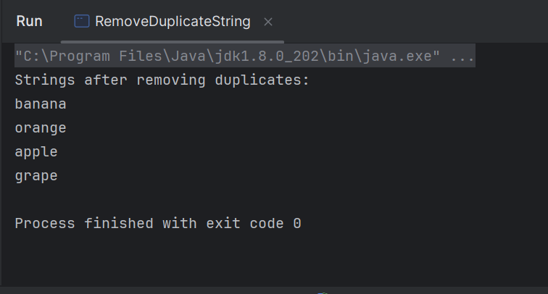

10- Write a java program to remove special character
input: A#b%₹#!&%cdef

Code:
public class RemoveSpecialCharacter {
public static void main(String[] args) {
// Example input string
String input = "A#b%₹#!&%cdef";
// Replace all non-alphanumeric characters with an empty string
String result = input.replaceAll("[^a-zA-Z0-9]", "");
// Output the result
System.out.println("String after removing special characters: " + result);
}
}

Output:
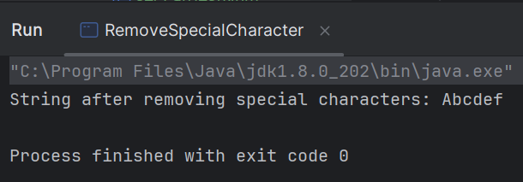

11-Write a java program to reverse a String

1. Using StringBuilder (Efficient)

Code:
public class ReverseString {
public static void main(String[] args) {
// Example input string
String input = "Hello World!";
// Using StringBuilder to reverse the string
StringBuilder reversed = new StringBuilder(input);
reversed.reverse();
// Output the reversed string
System.out.println("Reversed String: " + reversed.toString());
}
}

Output:
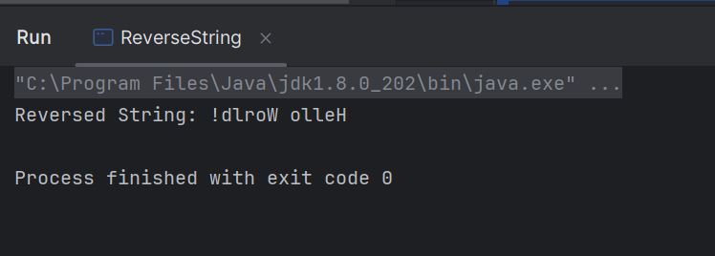

2. Using a Manual Approach (Loop)

Code:
public class ReverseStringUsingLoop {
public static void main(String[] args) {
// Example input string
String input = "Hello World!";
// Initialize an empty string to store the reversed string
String reversed = "";
// Loop through the input string backwards and build the reversed string
for (int i = input.length() - 1; i >= 0; i--) {
reversed += input.charAt(i);
}
// Output the reversed string
System.out.println("Reversed String: " + reversed);
}
}

Output:
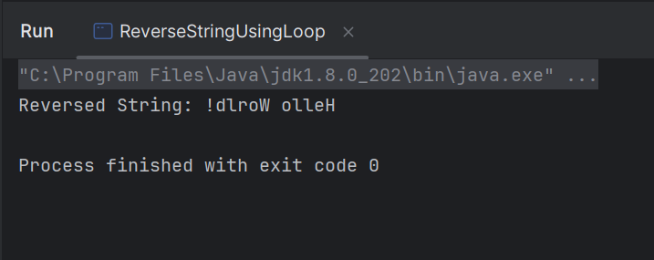

12- Write a java program string compressor
A string compressor is a program that takes an input string and compresses it by reducing consecutive repeated characters into a single character followed by the number of times it repeats.
For example:
- Input: "aaabbbcccd", Output: "a3b3c3d"

Code:
public class StringCompressor {
public static void main(String[] args) {
// Example input string
String input = "aaabbbcccd";
// Compress the string
String compressed = compressString(input);
// Output the result
System.out.println("Compressed String: " + compressed);
}
// Method to compress the string
public static String compressString(String input) {
// If input is empty or contains a single character, return it as is
if (input == null || input.length() == 0) {
return input;
}
// Initialize an empty StringBuilder to store the compressed string
StringBuilder compressed = new StringBuilder();
// Initialize a counter for consecutive characters
int count = 1;
// Loop through the string starting from the second character
for (int i = 1; i < input.length(); i++) {
// If the current character is the same as the previous, increment the count
if (input.charAt(i) == input.charAt(i - 1)) {
count++;
} else {
// Otherwise, append the previous character and its count to the compressed string
compressed.append(input.charAt(i - 1));
compressed.append(count);
count = 1; // Reset the count for the new character
}
}
// Append the last character and its count
compressed.append(input.charAt(input.length() - 1));
compressed.append(count);
// Convert StringBuilder to String and return
return compressed.toString();
}
}

Output:
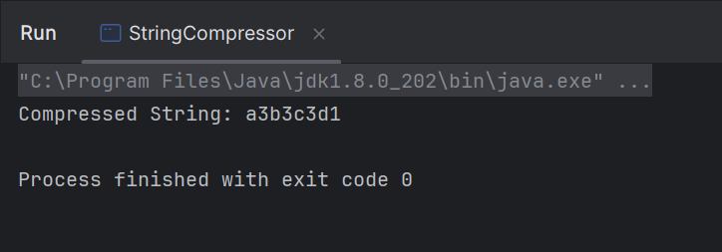

13- Patterns-
13. Patters programs
Triangle, Right angle triangle, Left angle triangle, Inverted right angle triangle, Inverted Left angle triangle, Pyramid triangle, Diamond,

Simple square
Formula to write for loop
Int i=5;
If we take i=0 then i <n should be taken
If we take i=1 the i<=n should be taken

Program:
public class SquarePattern {
public static void main(String[] args) {
int n= 7;
for(int i=1;i<=n;i++){
for(int j=1;j<=n;j++){
System.out.print("* ");
}
System.out.println(" ");
}
}
}

Output:
* * * * *
* * * * *
* * * * *
* * * * *
* * * * *
---------------------------------------------------------------------------------------------------------------------------------

Right angle triangle or increasing triangle
Here, only change we have to do is inner for loop j<=i , instead of j<=n.
So, every time while printing the columns it will take the size of rows that is – i .Hence I’s vale will increment each iteration so the column values will print that many times .

Program:
public class RightAngleTriangle {
public static void main(String[] args) {
int n=5;
for(int i=1;i<=n;i++){
for(int j=1;j<=i;j++){
System.out.print(" * ");
}
System.out.println(" ");
}
}
}

Output:
*
* *
* * *
* * * *
* * * * *
-------------------------------------------------------------------------------------------------------------------------

Decreasing triangle
Here, we are changing j’s value starting from I’s value, so that the column will print * for I’s value times.
Program:
public class DecreasingTriangle {
public static void main(String[] args) {
int n=5;
for(int i=1;i<=n;i++){
for(int j=i;j<=n;j++){
System.out.print(" * ");
}
System.out.println(" ");
}
}
}

Output:
* * * * *
* * * *
* * *
* *
*
-------------------------------------------------------------------------------------------------------------------------------------

Equilateral triangle/ Simple triangle

Program:

public class EquilateralTriangle {
public static void main(String[] args) {
int n=5;
for(int i=1;i<=n;i++){
for(int j=i; j<=n;j++){
System.out.print(" ");
}
for(int j=1;j<=i;j++){
System.out.print("* ");
}
System.out.println();
}
}
}

Output:
*
* *
* * *
* * * *
* * * * *

-----------------------------------------------------------------------------------------------------------------------------

Left Angle triangle

Program:
public class LeftAngleTriangle {
public static void main(String[] args) {
int n=5;
for(int i=1;i<=n;i++){ //to print rows
for(int j=i; j<=n;j++){ //to print columns with empty spaces
System.out.print(" "); //give two space to get left angle triangle
}
for(int j=1;j<=i;j++){ //to print * for columns
System.out.print("* "); //give one space after the star
}
System.out.println(); //to go to next line after each row
}
}
}

Output:
*
* *
* * *
* * * *
* * * * *






